Maintenance Plans Database (Tables in ISSQuestionaire Database)

# Table Structure (The relationships are not forced)

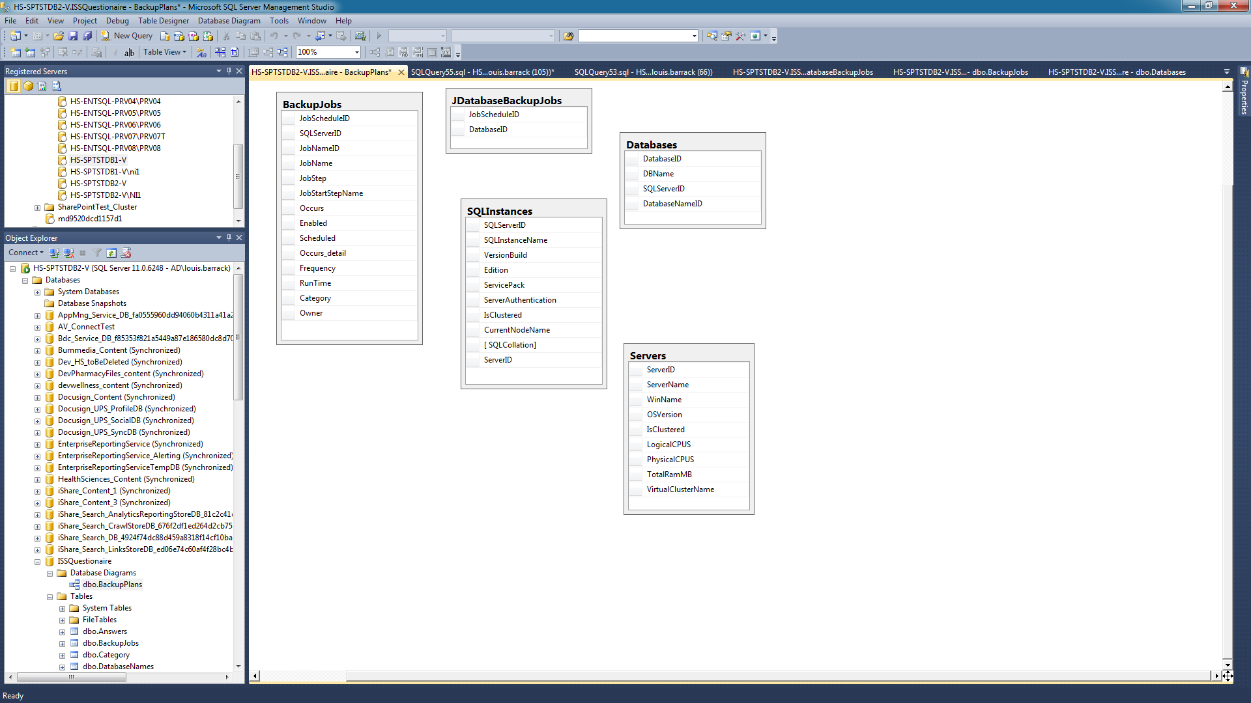

# SQL Query to Retrieve Backup Data

select

S.ServerName,

s.WinName,

s.OSVersion,

Case

When s.IsClustered IS NULL then 'No'

When s.IsClustered = 1 Then 'Yes'

When s.VirtualClusterName <>' ' Then 'Yes'

Else 'No'

End as SQLCluster,

s.VirtualClusterName,

s.LogicalCPUS,

s.PhysicalCPUS,

S.TotalRamMB,

SQ.SQLInstanceName,

sq.VersionBuild,

sq.Edition,

sq.ServicePack,

sq.ServerAuthentication,

sq.CurrentNodeName,

DI.DBName,

DI.DatabaseID,

JobName,

BJ.JobStep,

JobStartStepName,

Occurs,

Occurs_detail,

Frequency,

RunTime,

Owner

From BackupJobs BJ

Join JDatabaseBackupJobs DJ on dj.JobScheduleID = bj.JobScheduleID

join Databases DI on DI.DatabaseID = DJ.DatabaseID

join SQLInstances SQ on SQ.SQLServerID = DI.SQLServerID

Join Servers S on S.ServerID = SQ.ServerID

--where dI.DatabaseID = '23' ----to find specific Database info

Order By S.ServerID, BJ.SQLServerID,DI.DBName,JobName,JobStep

Sample Output – Server Info

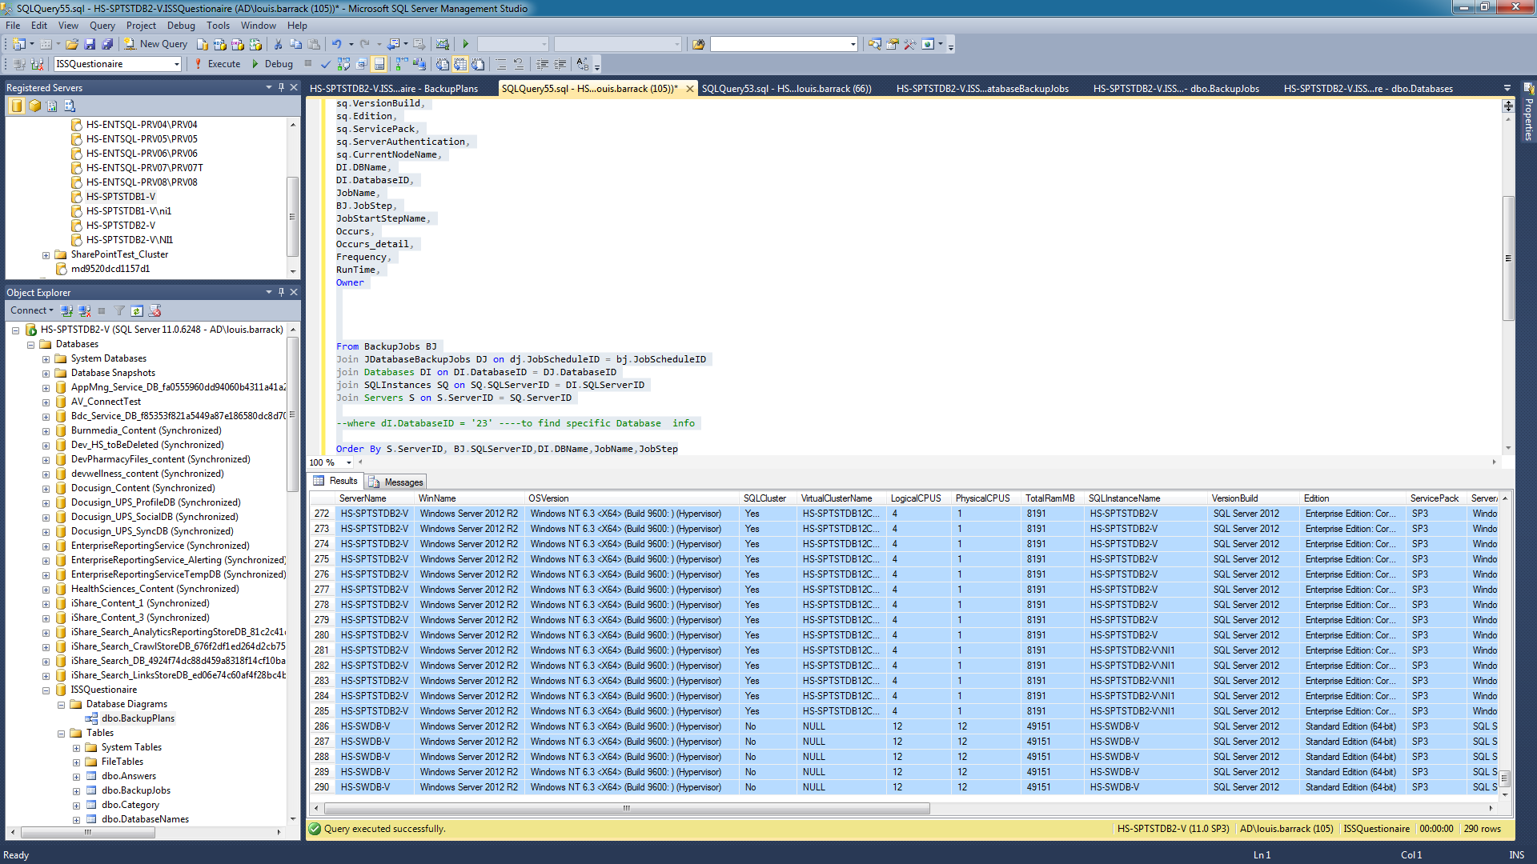

Sample Output – Sql Server Info

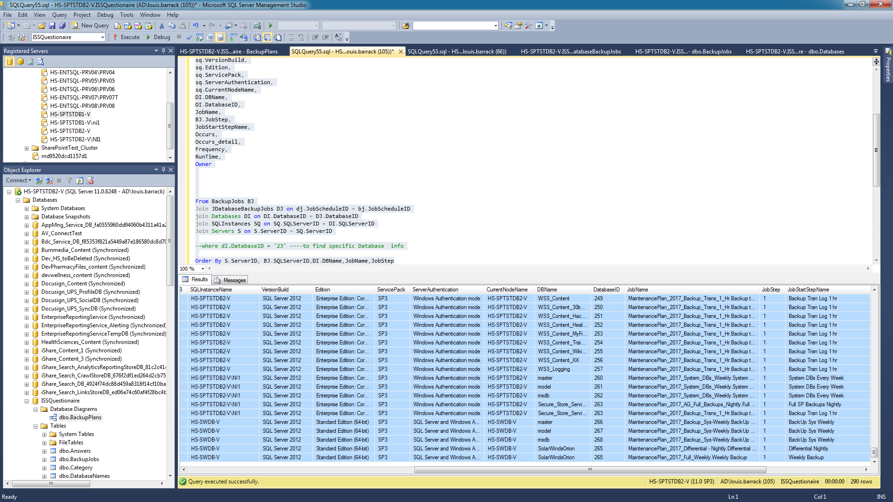

Sample Output – Backup Plans Info

